Greetings Ringgold Middle School Band Parents. Hopefully, your child came home last Thursday afternoon and told you about the Snap-Raise fundraiser that we will be participating in over the next month. We wanted to supply you with a few more details about this fundraiser and a quick tutorial on logging in to your child's Snap-Raise account and what to do once you are in the account.

First, let's talk about Snap-Raise, how it works and how the funds will be used.

Snap-Raise does not require us to sell anything. We simply provide email addresses of our family, friends, coworkers, etc. to Snap-Raise and they send out support requests to the addresses we entered. The first question I asked was, "Will Snap-Raise sell the email addresses to 3rd parties so they can spam us forever?" The answer to that question is a resounding "No". Snap-Raise makes their money by deducting 20% of the total of our donations received. They do not sell the addresses for additional profit. They enjoy having repeat customers and having their customers spammed by 3rd parties would drive away the opportunity for repeat business. The fundraiser lasts for four weeks. During that time period, the maximum number of emails an address would receive is five. One initial email at the start of the fundraiser and then one each week until the end of the fundraiser. If a donation is made, the emails to that address stop. This is a low effort, high return method for raising funds. Last year the Ringgold High School Band participated in a Snap-Raise fundraiser and raised over $16,000 dollars of which over $13,000 went to the band. Using the number of students in the middle school band and the average donation for our area, we could expect to raise $12,000 to $15,000 for the middle school band. These funds would be used for many uses including but not limited to: replace and repair the school owned instruments and purchase additional instruments to bolster the band's capabilities, pay for specialized instructors, update the band uniforms, purchase music and many more uses.

Secondly, let's review signing up and logging in to Snap-Raise, which your child should be able to do at this point.

Last Thursday, each student set up an account in Snap-Raise (www.snap-raise.com).

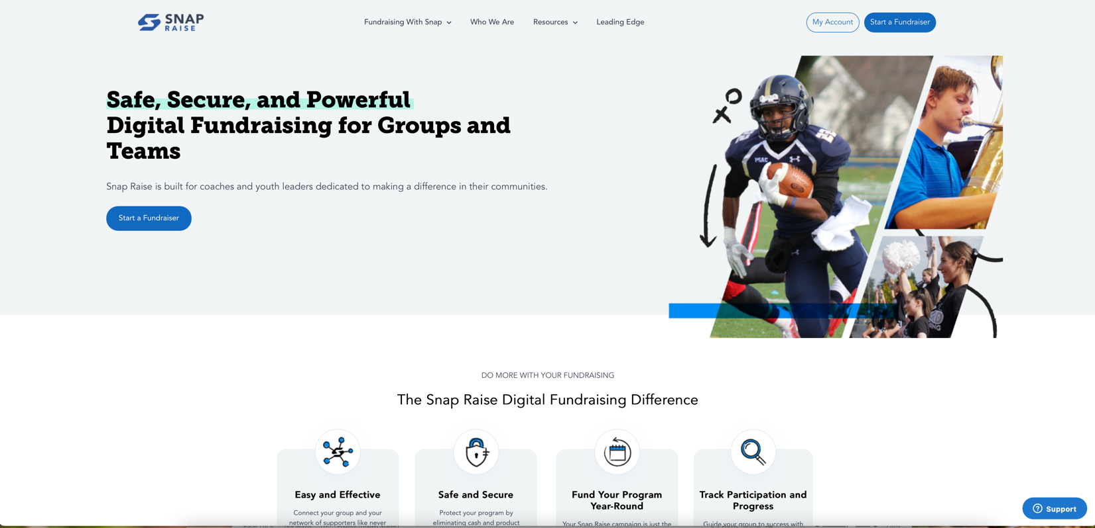

They had the option of using their school email address or a personal email address to set this account up. If they cannot remember what email address they used, simply go to the Snap-Raise web site and set up a new account. The page will look like this.

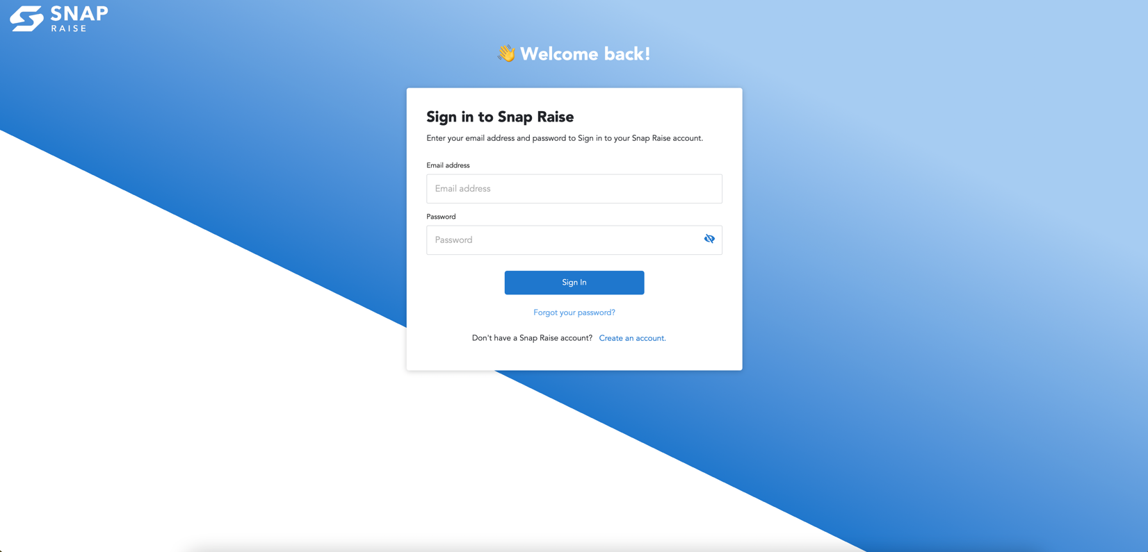

Enter an email address. The password should be set to 123456. Every account has this password so we can assist if problems arise. Do not fear hacking or any harmful action on this account. You will have no sensitive personal data stored in this area. So, to repeat, use 123456 as the password. When signing the students up last Thursday, we had a few that used ringgoldband@gmail to set up their account. If your child has this address as their account, please set up a new account with their student email address or a personal email address.
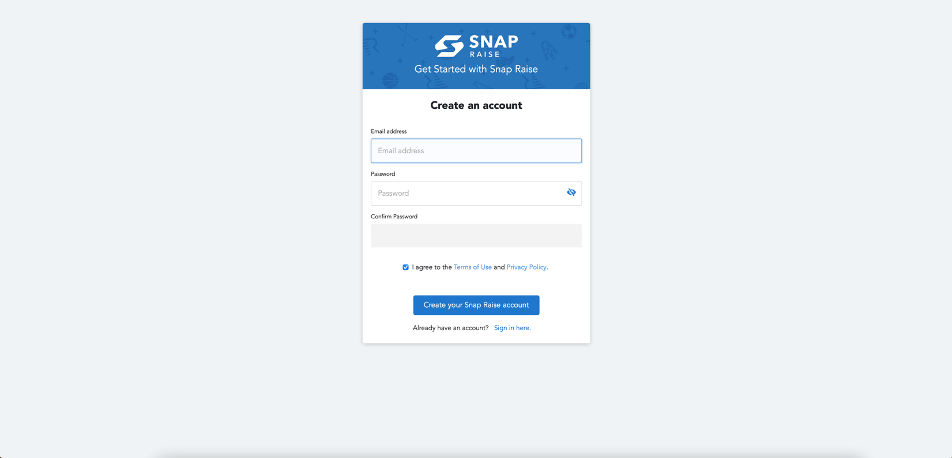
Once you have entered the email address and password (123456), Another screen will pop up asking you to enter your first and last name and a phone number. Click the Save and go to the home page button.

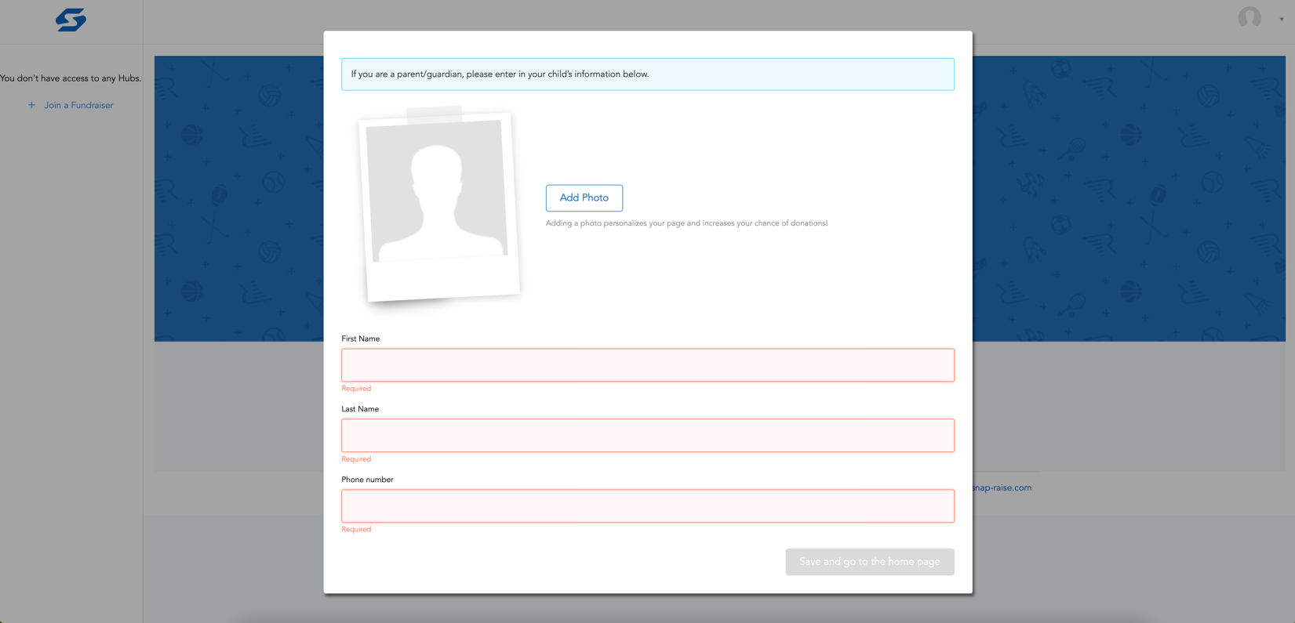

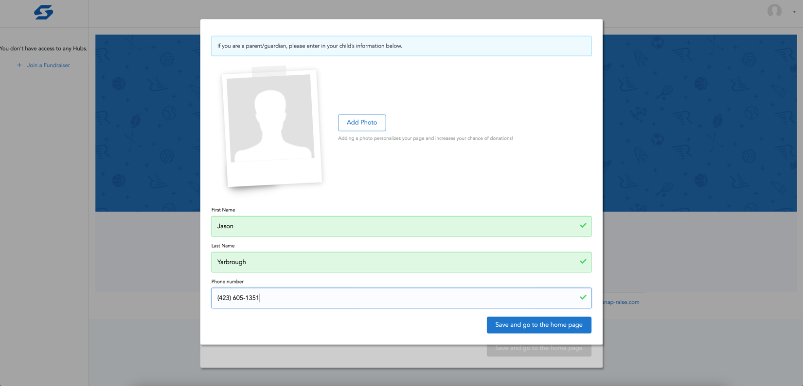

Now you will be asked to enter the Join Code. It is 557-242-779. Then click Join.

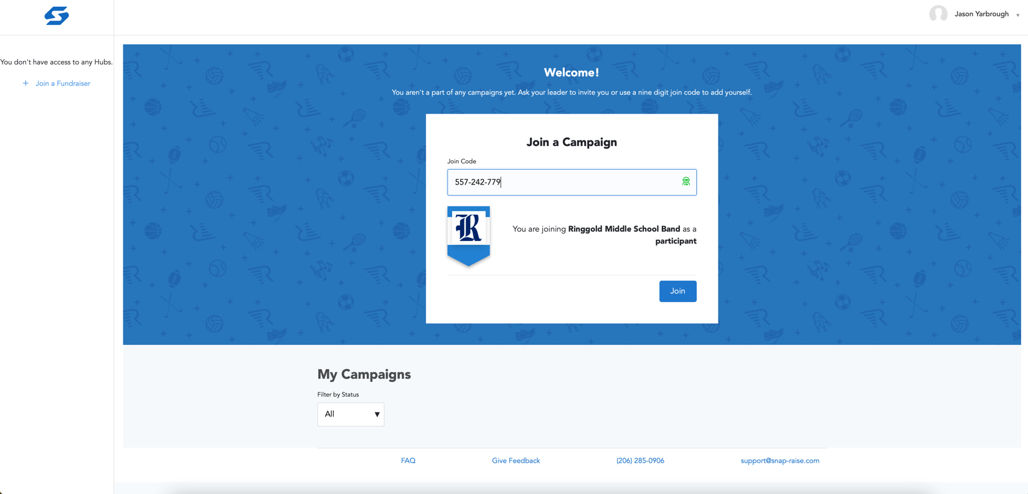

Once that information is entered you will be asked to confirm. Click Save and Continue.

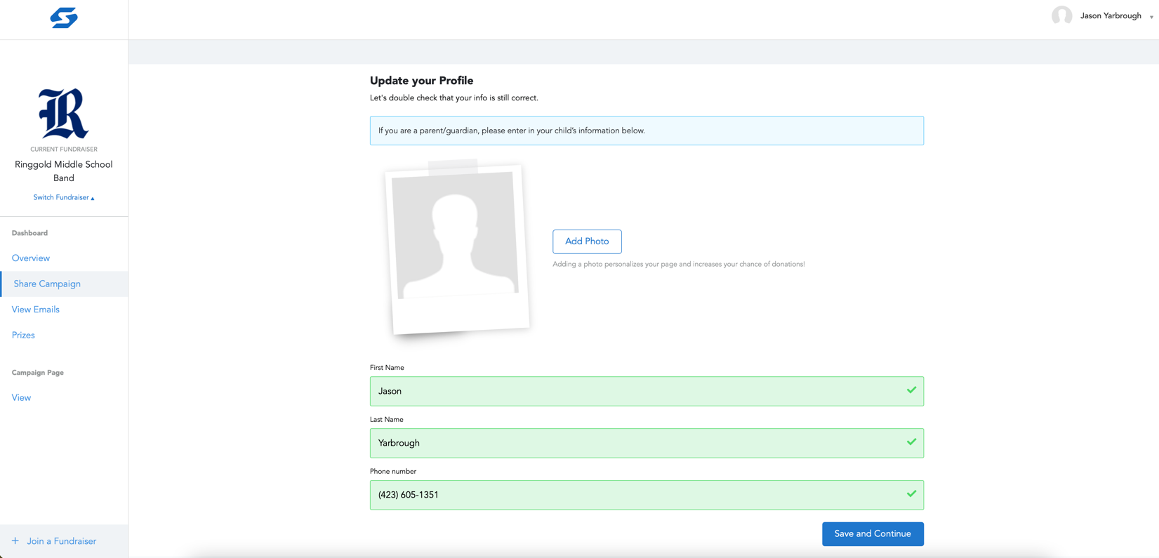

Now we arrive at the end of the road for the work we have to do to participate...enter the email address of those you wish to request to donate. If your child remembered all the information for last Thursday, you should have been brought straight to this page. Simply type in the email addresses in the box and click submit. Our goal is twenty email addresses per student. Feel free to use more if you would like.

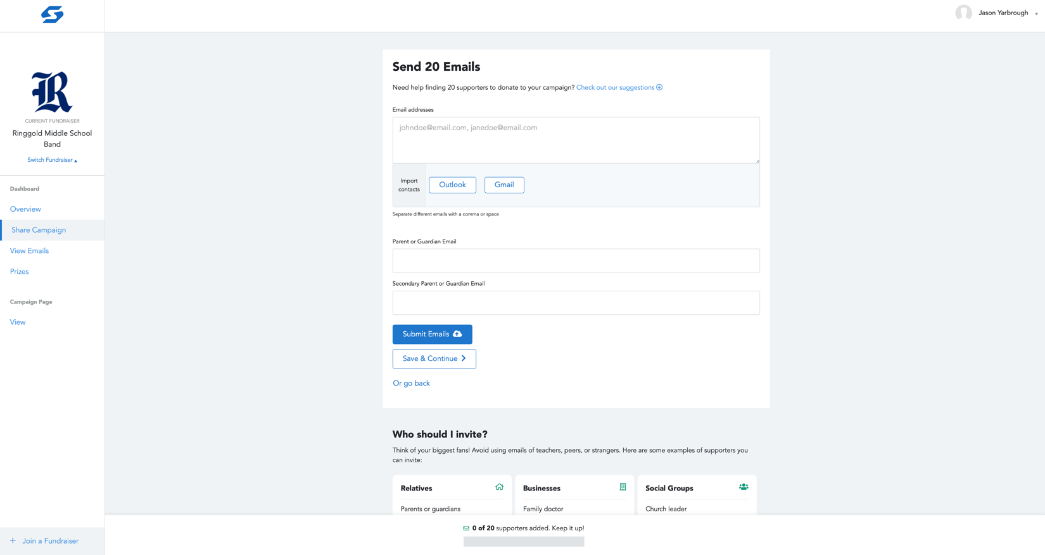

This go live date is set for Tuesday November 9th. The initial email will be set out that morning and the donation can begin.

Some additional tips to increase the likelihood of donations is to post on social media that your child is participating in Snap-Raise and if someone would like to support them, post or PM their email address. Text messages can also be used to send out requests.

If you have questions, please email Jason Yarbrough at rmtbtreasurer@gmail.com.

